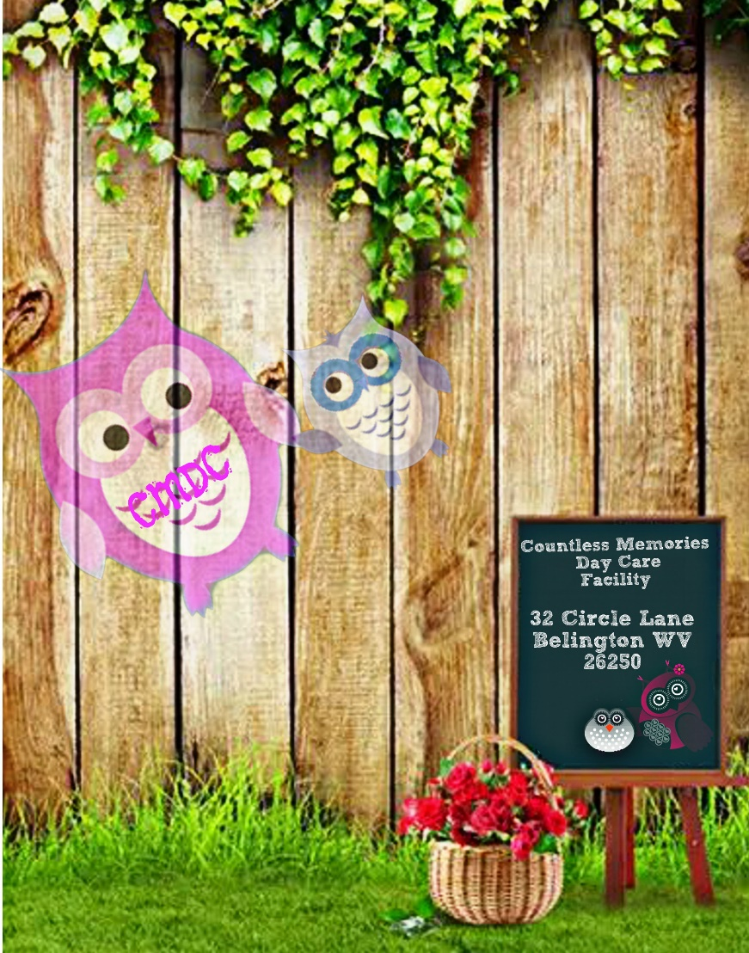
Countless Memories
Day Care
Parent ‘Handbook'
Policies and Procedures

Revised 07/14/2016

Countless Memories Day Care

TABLE OF CONTENTS
Title | Policy | Page
Welcome | 1 | 2
Mission Statement | 1.1 | 2
Child Care Philosophy | 1.2 | 2
Non-discrimination Statements | 1.3 | 2
Religion | 1.4 | 2
Admission Requirements | 1.5 | 2
Communication | 2 | 3
Hours of Operation | 3 | 3
Rates/Fees | 4 | 5
WE ARE A SMOKE FREE FACILITY | 5 | 4
Inclement Weather Policy | 6 | 5
Health and Wellness | 7 | 5
Injury/Accident | 8 | 8
Facility Insurance | 9 | 9
Child Abuse/Neglect Policy | 10 | 9
Discipline Policy | 11 | 10
Meals/Nutrition | 12 | 10
Activities and Curriculum | 13 | 10
Parent Involvement | 14 | 11
Transportation | 15 | 11
Potty Training | 16 | 11
Animals | 17 | 12
A Final Note | 18 | 12
Handbook Acknowledgment | *** | 13

Welcome:
Welcome to Countless Memories Day Care Facility. To facilitate greater understanding between us, we have created this handbook. It covers our childcare philosophies, business policies and expectations. It is our pleasure to meet your family and we look forward to a long and joyous journey together. Please read this handbook carefully, and feel free to discuss with us any questions that you may have.

Mission Statement:
Here at Countless Memories we strive to assist the physical, cognitive, social, and emotional development of each child. We aim to provide a safe, supportive and nurturing atmosphere where all children are able to express their creativity freely. We believe that children gain a sense of security from knowledge that there are consistent, responsible limits and that these limits are designed to nurture them and protect them. We recognize that each child is an individual. We provide an environment that promotes the complete development of children preparing them to advance to a school age education program.

Child Care Philosophy:
The curriculum at Countless Memories Day Care Facility will provide children with developmentally appropriate early childhood experiences that stimulate learning in all developmental areas and focus on age appropriate learning environments and individual needs. Countless Memories will provide an atmosphere that will facilitate a balance between child-initiated, child-directed and provider-supported interactions. All activities are geared around individual needs of all children participating in the program.

Non-Discrimination Statement:
Countless Memories does not and shall not discriminate on the basis of race, color, religion (creed), gender, gender expression, age, national origin (ancestry), disability, marital status, sexual orientation, or military status, in any of its activities or operations. These activities include, but are not limited to, selection of clientele, hiring and firing of staff, selection of volunteers and vendors, and provision of services. We are committed to providing an inclusive and welcoming environment for all members of our clients, staff, volunteers, subcontractors, and vendors.

Religion:
Countless Memories Day Care Facility does not and shall not discriminate on the basis of religion. We open arms to any and all religious beliefs. We also ask that our clients do not discriminate on others religious beliefs. Rude remarks or harmful words and actions will result in exclusion from our facility.
Admission Requirements:
Countless Memories Day Care Facility accepts children ages birth to 10 years. No child will be admitted into the facility without all forms provided in the “Welcome Packet” filled out, turned in, and approved by administration. All children have to have a completed and updated physical exam, immunization record, completed allergy notifications, emergency contact sheet, and all registration forms. Upon acceptance, parents and staff will decide upon a day and time agreement for the child’s stay at our facility.
Communication:
Communication is very important to us. When we accept a new family into the facility, we like to be sure that we can share openly any concerns or questions that may arise. It is important that there is a similar childcare philosophy between us. We welcome questions, feedback, or discussions of any kind that are oriented towards a positive outcome for the child(ren). Sensitive issues will be discussed in private, outside of regular childcare hours either by telephone or conference. Conferences will not be scheduled as a routine part of your child's care; however, should you like to have a conference, you may request one at any time. We intend to publish a monthly newsletter that will explain some of the activities we are doing, our current curriculum themes, events that will be happening during that month, and any other pertinent or fun information that may be of interest to you. You are always welcome to contribute to our newsletter.

Hours of Operation:
Normal hours of operation are Monday through Friday from 7:00 a.m. to 7:00 p.m. ( A schedule that is needed until 7:00 PM must be scheduled ahead of time. We do offer hours until 7:00 PM, but we do leave when our last child does. We do need advanced notice for Hours after 5:30 PM) your specific hours will be outlined in your Contract and Rate Agreement. We require a 2 week notice if you need to change your enrollment hours.
The facility is closed:
New Year’s Day
Memorial Day
July 4th
Labor Day
Thanksgiving Day
Christmas Eve *Open from 7:00 a.m – 1:00 p.m
Christmas Day
Sick/Personal Days
As strong as our immune system has become over the years, we unfortunately still get sick from time to time. Because of this we allot ourselves five sick/personal days per year. We also use these days for our continuing education classes (CPR, Pediatric First Aid, etc) in order to keep our childcare license in good standing. Of course we will give you as much of an advance notice as possible if we have no available staffing for the day.
Vacations
We allot ourselves two weeks of vacation a year. The dates of our vacation will be posted at least one month in advance. The Facility will remain open unless we have no available staff, in this case, you will receive adequate notice.
Note: Parents are responsible for finding back-up care for their children during provider vacations, holidays, and sick/personal days resulting in the daycare closing.
Rates/Fees:
* Scheduled Days are paid days unless we are given 24 hours’ notice of absence
Your specific rates will be outlined in your Contract and Rate Agreement. Payment is payable in advance and is due no later than drop off time on the first contracted care day of each week, unless another arrangement has been agreed upon. You are still responsible for paying all fees for your contracted days on your outlined payment date. Outlined payment dates will be constituted on a personalized basis upon registration. Weekly rates will be due every Friday or the child will not be able to attend on Monday, Biweekly rates will be due every second and last Friday of the month, or the child will be unable to attend on Monday, and monthly rates (which must be agreed upon in advance) will be due on the last Friday of each month. If an occurrence arises to where your payment is late, a late fee may be added unless we are notified ahead of time and agree on a special circumstance payment plan. (Special circumstance payment plans will not be accepted regularly outside of your outlined payment schedule.) If your payment day is a holiday, payment is expected on the previous day. If you go away on vacation, payment is due BEFORE you leave. In cases of illness, your payment is still expected unless other arrangements have been previously made. Payments may be made by check or cash. Checks must be dated for the day they are due, no post-dated checks will be accepted. Repeated late payments may be grounds for termination and your deposit will be non-refundable.
Non-Sufficient Checks
Due to the inconvenience of NSF checks, a $35.00 fee will be charged for NSF checks, your child’s position will be placed on hold until all funds are received. Please note: if a NSF check is received, we reserve the right to remove your check as form of payment, and will then only accept cash. If the rates and fees are not caught up within a week’s time, your child will be removed from the facility roster and legal action will be taken.
NON-SMOKING facility:
Countless Memories is a NON-SMOKING facility. Administration, staff, and parents are not to smoke on our grounds or in our building. This pertains to other forms of tobacco, alcohol, and/or illegal drugs. This policy is firm and is not up for discussion.
Inclement Weather Policy:
*Countless Memories will allow children to play outside in weather up to 40 degrees. Parents must send child with appropriate clothing for these days.
In the event of inclement weather, Countless Memories Day Care Facility will make every attempt to open as usual. However, to preserve the safety of our staff and children we will close if conditions warrant such action. It is at the discretion of the Facility Administration to make the decision to close earlier or open later due to natural disasters (i.e. Snow, ice …)
Countless Memories Day Care Facility Families will be notified of the decision, prior to 6:00am, in the following ways:
• Call or text from office Cell.
• Countless Memories Facebook Page/website/Email
If the Facility is open, but because of severe weather and/or road conditions Administration decides to close early, families will be notified by phone.
The Facility will be closed or close early in the instance of a State of Emergency notice.
Health and Wellness:
COMPLAINS OF PAIN
Signs/symptoms of disease including: Severe coughing, sneezing, breathing difficulty, discharge from the nose, ears or eyes, diarrhea or vomiting.
Should any of these symptoms present themselves the child will be excluded until a medical evaluation allows inclusion. A doctor’s note must be submitted stating that the child is not contagious and indicating the date that they can return to daycare.

In order to minimize the spread of illness among children, it is important that parents have arrangements available for alternative care whenever your child shows signs of illness. The following symptoms will necessitate exclusion from the center:

FEVERS
A temperature of 100° F or higher is reason for exclusion from group care. A child who has been sent home with a fever of 100° F or higher may return to the center after being fever free for 24 hours without any medication.

SEVERE COLDS
Colds with extreme symptoms of excessive coughing, sneezing, nose drainage that is yellow or green and that interferes with a child’s ability to eat, sleep or play are reason for exclusion.

DIARRHEA
Bowel movements that are extremely loose, watery and frequent are reasons for exclusion. A child should be free from diarrhea for 24 hours before returning to the center.
EXPLANATION – Diarrhea in children is an extremely contagious illness. Bowel movements that cannot be contained in a diaper or a toilet pose a high risk of contagion. Young children, especially infants, may have frequent or loose stools regularly or in response to a variety of conditions, but these are different from diarrhea. One or two meals should be eaten during the “24 hours free from diarrhea” (overnight with no meals eaten should not be considered 24 hours free from diarrhea). Secondary symptoms of crying, pain, refusal to eat, etc., must be considered.

VOMITING
Vomiting is a reason for exclusion. As with diarrhea, 24 hours should pass (with at least one meal eaten) without an episode of vomiting before a child returns to the center.
EXPLANATION – infants can spit up or throw up for many different reasons. With no other symptoms present we would wait to see if an infant threw up a second time before calling the parent to pick up the child.

RASHES
Rashes must be physician diagnosed for a child to be in the center.

MOUTH SORES
Mouth sores with drooling are reason for exclusion, unless the child’s pediatrician states the child is non-infectious.

CONJUNCTIVITIS
Pink or red conjunctiva with white or yellow discharge, often with matted eyelids after sleep, and including a child with eye pain or redness of the eyelids or skin surrounding the eye is reason for exclusion. A child may return to the center 24 hours after medication is begun.

TEETHING
Teething is not a reason for exclusion. Teething can cause low-grade fever (under 100 F), crankiness, loose bowel movements and a clear, runny nose. Teething does not cause the exclusionary conditions described above, though.

SYMPTOMS OF CONTAGIOUS CHILDHOOD DISEASE
Symptoms of contagious childhood diseases are reason for exclusion. The center however, adheres to the Americans with Disabilities Act in the application of its disease policies.

Parents should notify us if their child has been exposed to Measles, Chicken Pox, Roseola, Conjunctivitis (pink eye), Impetigo, Pediculosis (head lice) RSV, Bronchiolitis, Strep Throat, Ringworm and Coxsackie. Exposure to contagious disease is not reason for exclusion.

SIGNS OF POSSIBLE SEVERE ILLNESS
Signs of possible severe illness, including unusual lethargy, undefined irritability; persistent discomfort crying or difficult breathing are reasons for exclusion.
HEAD LICE
Parents will be called to come pick up their child should head lice present. Parents will will be notified if the education system sends home a letter stating that head lice has be found in the schools. Parents will be notified that an outbreak has presented, but will never be gived information on the carrying child.
ABSENCE
Please call the center if your child will be absent and let us know why. Contagious illnesses must be posted in the classrooms, so other parents know what is going around. To be cleared by a pediatrician for group care, we need:
1. the child to be seen by a doctor,
2. a note from the doctor stating
(a) a diagnosis
(b) that the child is not contagious
(c) the date that the child may return to group care

A child will continue to be excluded if the appropriate note is not received before the child is brought to the facility.
*** WV State Law requires we obtain a valid, up to date physical exam form and updated shot record. ***

Injury/Accident:
Basic first aid will be performed. In the event of a serious injury, a parent will be notified. If the parents are not available, the emergency numbers on the child’s emergency card will be called. If the person(s) cannot be reached, the child will be taken to the closest hospital or Emergency Room, unless the parents have designated a different emergency plan.
IF YOUR CHILD BECOMES ILL AT THE CENTER
If your child becomes ill while at the center, we will call you; if you cannot be reached your emergency contacts will be notified and asked to pick up your child. Please ensure that emergency contacts are aware that they have been listed on your emergency contact list. Please be sure to notify us the very day your work phone number changes, so that you are most efficiently reached. Children with contagious illnesses need to be picked up within a reasonable amount of time to limit their exposure to the other children.
REPORTABLE ILLNESSES
Some childhood illnesses are required, by law, to be reported to our local health agency. In the case of a contagious illness in your child’s class, we will post a notice by the sign-in/out sheet in the entrance area.
EMERGENCY PROCEDURES
In the event that the children would be safer remaining indoors, we would shelter them inside the Countless Memories Day Care Facility. If our building was not considered to be a safe place for the children, we would relocate to a designated space. Next we would begin calling parents to advise them of our location and to request that the children be picked up as quickly and safely as possible. For cases where parents cannot be reached we would begin to call your emergency contact numbers.
Please make sure your child/children have a sheet, blanket and additional clothing appropriate for the season at all times.
If your child is on formula, please supply an additional can of ready to feed formula.
Facility Insurance:
For the health and safety of your child(ren) and our staff, our facility as required by the state of WV is required to purchase, and maintain liability insurance. Please file any expenses incurred with your medical insurance carrier or with Medical Assistance. The Countless Memories insurance policy has a liability insurance policy which only covers personal injuries for which Countless Memories is legally liable. It does not pay for injuries that are the result of accidents.
Child Abuse/Neglect Policy:
All staff of the Countless Memories Day Care Facility are mandated reporters and are required to report any suspected abuse, neglect, or maltreatment on the part of an employee, parent, or volunteer. Any abuse or maltreatment of a child, either as an incident of discipline or otherwise is prohibited. Any means of corporal punishment will not be tolerated. Additionally, withholding or using food, rest or sleep as a punishment is prohibited. If any type of abuse or neglect is suspected it will be reported to the State Central Registry at the mandated number – (1-800-352-6513)
“The purpose of required reporting is to identify suspected abused and neglected children as soon as possible so that they may be protected from further harm. Child Protective Services cannot act until a report is made.
West Virginia Law (WV Code 49-6A-2) mandates that any person over the age of eighteen who receives a disclosure from a credible witness or observes any sexual abuse or sexual assault of a child, shall immediately and not more than forty eight hours, report the circumstances or cause a report to be made to the Department and the State Police or other law-enforcement agency having jurisdiction to investigate the report. If the reporter feels that reporting the alleged sexual abuse will expose themselves, the child, the reporter’s children or other children in the subjects household to an increased threat of serious bodily injury, the individual may delay making the report while he or she undertakes measures to remove themselves or the affected children from the perceived threat of additional harm. The individual must make the report as soon as practical after the threat of harm has been reduced. The law enforcement agency that receives a report regarding sexual abuse must report the allegations to the Department.

West Virginia Law also mandates that in any case where a mandated reporter believes that the child suffered serious physical abuse, the reporter shall also immediately report, or cause a report to be made, to the State Police and any law-enforcement agency having jurisdiction to investigate the complaint”
Discipline Policy:
Children who are having difficulty for any reason will be re-directed to another activity with teacher assistance. In the event that a child’s behavior is likely to result in harm to the child, others or property, or seriously disrupts group interaction, the child may be separated briefly from the group. The child will be taken up to the office to sit with an administrator where he/she can gain enough self-control to rejoin the group. The child will always be left in an area where he/she is in full view of, and can be supervised and supported by a staff member. Interaction between the child and a staff member will take place immediately following the separation to guide the child toward appropriate group behavior. A method of discipline which frightens, demean, or humiliate a child is strictly prohibited.
Meals/Nutrition:
Breakfast is served only between 7:30 and 9:00 a.m.; children arriving later should already have eaten at home.
The major meal of the day is served at lunch; dinner is lighter fare. Meals are prepared in facility using all necessary precautions to avoid the spread of germs. Nutritious snacks are provided. Milk is served at lunch to all children and made available, as needed, to infants in the bottles parents provide. However, parents must provide their own formula (or expressed milk for nursing infants if parents so choose) for those not yet ready for container milk.
Parents must inform the center of any special dietary requirements, including food allergies. Soda, candy and chewing gum are not permitted in the center.
The menu rotates on a two-week basis. When you enroll and when the facility menu changes, you will receive a copy of the scheduled meals. Please notify us of any allergies immediately.
Nutritional portions and standards are followed in accordance of the *Leap of taste WV child care nutritional standards.
Activities and Curriculum:
The curriculum at Countless Memories is designed to grab the attention of each child individually. We intend all activities to maintain a pre-educational standpoint, while also ensuring a fun-filled day. Each family will be given a weekly activities sheet explaining our plans for the week, as well as the monthly newsletter giving a partial plan for our month. All children will be assisted in building social skills to help prepare for future educational and social experiences. We know that children also learn through play; because of this, we do not under estimate its importance on a growing child's mind, body and spirit. Therefore, the children under our care receive lots of both free-play and structured-play throughout each day. During structured-play we primarily have only one group of toys or activity out at a time in order to allow the children to concentrate fully on each thing they do. Age appropriate activities will be scheduled with the flexibility allowed to respond to the needs of each individual child and their various ages.
Parent Involvement:
PARENT VISITS
Parents may visit the facility at any time. However, if there are problems arising from parent visits that interfere with the deliverance of quality childcare, then the parent(s) will not be permitted in the play area.
FAMILIES INVOLVEMENT
Families are welcome to participate in the daily activities and facility events.

WAYS FOR THE FAMILIES TO BE INVOLVED:
• Making things for the program
• Sharing their culture
• Sharing a talent or a job
• Participating in structured, preapproved activities
• Contributing to the curriculum
- Parent Volunteers will be accepted upon approval of a signed volunteer agreement.

Transportation:
Countless Memories currently does not offer in facility transportation. All transportation to and from our facility from home and school is the responsibility of the parent/guardian. In case of a severe injury, if parent/guardian and/or emergency contacts cannot be reached, emergency services transportation will be called.
Potty Talk:
Diaper Policy
It is the parent's responsibility to provide diapers, wipes, and diaper cream for your child. It is also the parent's responsibility to check periodically to see if or when your child needs more diapers, wipes, and cream, (not the providers). Each child has his or her own clearly labeled diaper bin, either in the infant/younger toddler room or older toddler/preschooler room, depending on the age of the child. Diapers are checked frequently, and changed as required. Diapers containing #2 are changed immediately. The diaper changing tables are cleaned and disinfected between each diaper change, and hand washing of childcare provider and child is performed after each diaper change.

Toilet Training
We are more than happy to encourage potty training as long as the child is ready (typically between 2 and 3 years old). The initial start needs to be done at home for at least two weeks with success before it can be effectively started at daycare, although we will do our best to help. Parents will be required to supply pull-ups and wipes. Children will be allowed to come to daycare in cotton training pants/underwear after they have been accident free for at least two weeks in pull-ups. Communication between parents and the daycare provider is imperative for a successful transition from diapers to toilet.
Animals
Countless memories does not have pets. We will not be boarding any pets, though we may, with notice, allow children to bring a pet in for a special show and tell day. The pets are to be within reason. NO rats, snakes, vicious dogs, etc. The pet owner must present proof of rabies vaccination before the pet can be brought in.
A Final Note
It is important that you feel comfortable with our policies and procedures. If you do not understand something, have a concern, or you feel uncomfortable with one or more of our policies and/or procedures it is important that you express that to us before enrolling your child in our daycare. We are always open to suggestions and feel communication is a very important part of a quality daycare. If there are any problems or concerns in the future, we encourage you to talk to us about them. If a lengthy discussion is needed, a time that is convenient for both of us will be scheduled, as the other children still need our attention during business hours. Thank you for the opportunity to work with you and care for your little one. We look forward to a future of keeping your child smiling and safe.

Note: By signing the Parent-Provider Contract/Enrollment Application, it is understood that all of the policies and procedures of Countless Memories Day Care Facility handbook are understood and agreed upon.

ACKNOWLEDGMENT OF RECEIPT OF PARENT HANDBOOK

The Parent Handbook contains important information about the facility, and I understand that I should consult the Administrator/Office Manager regarding any questions not answered in the handbook. I have entered into my parent/guardian – provider relationship with the Company voluntarily, and understand that there is rules and regulations that must be followed to maintain a position with Countless Memories.

Since the information, policies, and regulations described herein are subject to change at any time, I acknowledge that revisions to the handbook may occur. All such changes will generally be communicated through official notices, and I understand that revised information may supersede, modify, or eliminate existing policies. Only the Countless Memories administration has the ability to adopt any revisions to the policies in this handbook.

I have had an opportunity to read the handbook, and I understand that I may ask administration and staff any questions I might have concerning the handbook. I accept the terms of the handbook. I also understand that it is my responsibility to comply with the policies contained in this handbook, and any revisions made to it. I further agree that if I remain with Countless Memories following any modifications to the handbook, I thereby accept and agree to such changes.

I have received a copy of the Countless Memories Parent Handbook on the date listed below. I understand that I am expected to read the entire handbook. Additionally, I will sign the two copies of this Acknowledgment of Receipt, retain one copy for myself, and return one copy to the facility’s representative listed below on the date specified. I understand that this form will be retained in my child’s personnel file.

_________________________________________________________ ______/______/______

Signature of Parent/Guardian Date

__________________________________ ________________________________
________________________________
________________________________
Parent Guardian Name – Printed Child(ren) Name - Printed

Brittanni Haddix/Alyciann Simons ______/______/_______

Facility Representative Date

